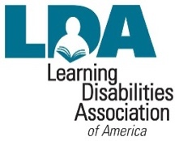
LDA MEMBERSHIP APPLICATION
REQUIRED
POSTAGE TO BE PLACED HERE

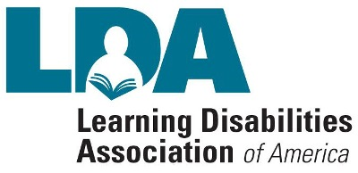

N A M E

Mail to: Learning Disabilities
Association of America (LDA)
PO Box 365,
Irmo, SC 29063
www.ldasc.org
A D D R E S S

C I T Y / S T A T E / Z I P

P H O N E N U M B E R

E - M A I L A D D R E S S

$25.00 Student Membership
(with verification of college enrollment and/or age.)

$55.00 Professional/Parent Membership
Website: http://ldaamerica.org/
Email: info@LDAAmerica.org
Facebook.com/LDAAmerica
Twitter.com/LDAofAmerica

I N T E R E S T
(Parent / Professional / Other)

SENDER MAILING ADDRESS

S I G N A T U R E

MEMBERSHIP DUES INCLUDES
NATIONAL & STATE LDA DUES.

Learning
Disabilities Association of America
A LEARNING DISABILITY IS:
A permanent disorder which affects the manner in which a person with average, above average, or gifted intelligence takes in, retains, and expresses information. Incoming or outgoing information may become scrambled as it travels between the eye, ear, or skin, and the brain. LD is commonly recognized as deficits in one or more of the following areas: reading comprehension, spelling, written expression, math computation, problem solving, problems in organizational skills, time management, social skills, and language based or perceptual problems.

A LEARNING DISABILITY IS NOT:
A learning disability is not a form of intellectual disability or an emotional disorder. However, when an individual is frustrated and confused on a daily basis emotional problems and behavioral problems may be a secondary result of learning disabilities.

WHAT IS LDA?
Chartered in 1964 by a group of concerned parents, the Association for Children with Learning Disabilities was formed on behalf of children with learning disabilities. Now known as Learning Disabilities Association of America, the association has over 50,000 members and state chapters in all 50 states. The association serves parents, professionals, and adults with learning disabilities.

All members will get a free subscription to our quarterly electronic newsletter and e-mail alerts on upcoming shows, events, and exhibits.

LEARNING DISABILITIES ASSOCIATION OF AMERICA

WHAT ARE LDASC’S GOALS?
Learning disabilities (LD) occur in many forms: visual, auditory, motor control, communication, logic, etc. Effective intervention includes an approach that meets the individual educational, physiological, psychological, & medical needs of the child. LDASC believes in an interdisciplinary approach to these major goals:

•ENCOURAGE research in neuro-physiological and psychological aspects of LD.
•STIMULATE development of early detection programs.
•CREATE acclimate of public awareness and acceptance.
•DISSEMINATE information widely.
•SERVE as an advocate.
•IMPROVE regular and special education.
•ESTABLISH career opportunities.
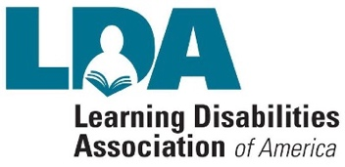
•PROMOTE the prevention of LD through research.

EXECUTIVE BOARD MEMBERS
Dr. Analisa L. Smith President
Ann Whitten Vice President
Debbie Gladden Treasurer
Dr. Amy Gregory Co-Secretary Anne Fogel Co-Secretary Dr. Tammy Graham Advisor James Smith Advisor Hetlena Johnson Advisor

